Create Replica Sets in Mongo DB

First of all create 2 folders names data1 and data2 in any location

Execute below mentioned command

**mongod –port 27018 –dbpath “path of data1 folder” –replSet rs0**

**mongod –port 27019 –dbpath “path of data2 folder” –replSet rs1**

**Connect with 27018 instance**

mongo –port 27018

For, primary secondary config execute below command

rsconf= {_id: “rs0” , members: [{_id:0,host:”localhost:27018”}, [{_id:1,host:”localhost:27019”}]}

rs.initiate(rsconf);

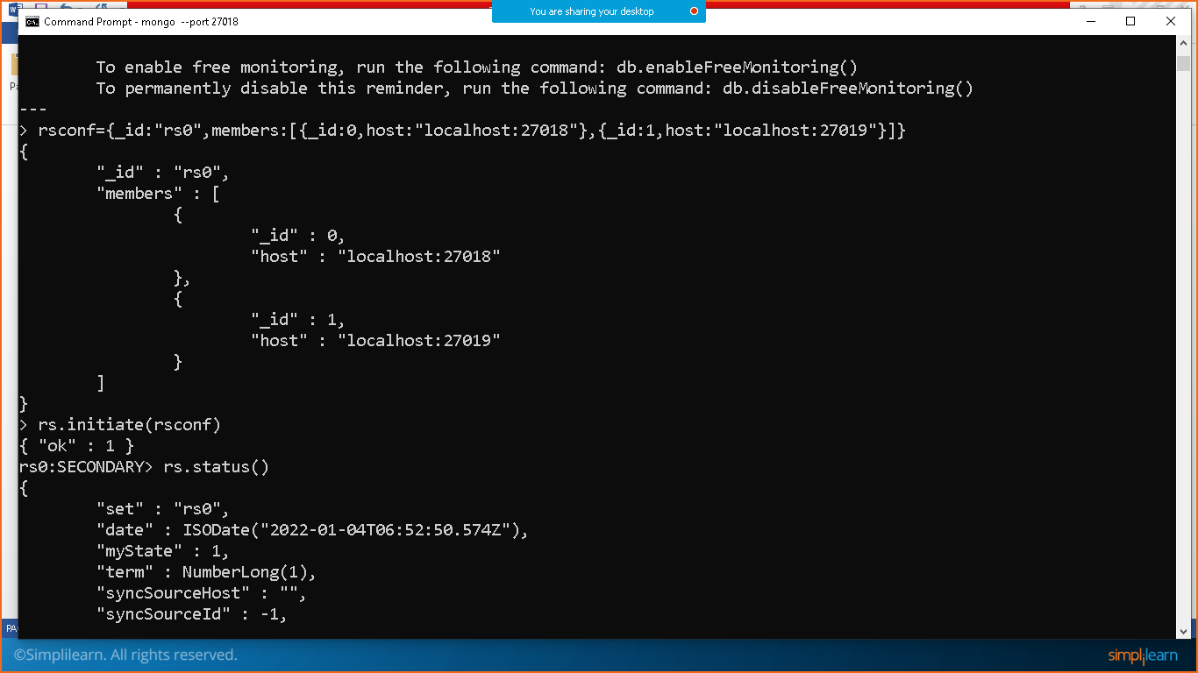

Execute rs.status();

